CSIT214 Weekly Meeting:
Group ID:
T11
Week 11:
Meeting Date: Week 11 (Thursday 21 May)
Group Members:
- Zac Wastie
- Jay Segar
- Nikita Kravchenko
- Zexi Dong
- Sui San Cheung
Focus for this week.
The focus for this week was to discuss the presentation
Progress Report

Week 11 started on the Monday with our Lab which we had one member missing but decided to put a meeting on Thursday to discuss the presentation. The meeting started at 3pm and went for 1hr where we talked the presentation that Zexi had created. The PowerPoint looked good, but we had some improvements we added with one being that the presentation would be to only and we had to trim it down. We also had some changes on our website design so that it looked blue and white which are the requirements. We are still yet to decide who will be presenting with our project manager, but he wants to have one more member up with him. We have a poll that closes on Sunday and we will see who the other presenter is.
Jay is finishing up the actual Gantt chart and as a group we could all see the difference in it from the proposed one. Over the weekend all the group members will have to add information to one side to make it look better or fix it up to make it look good for stakeholders.

Our Roles
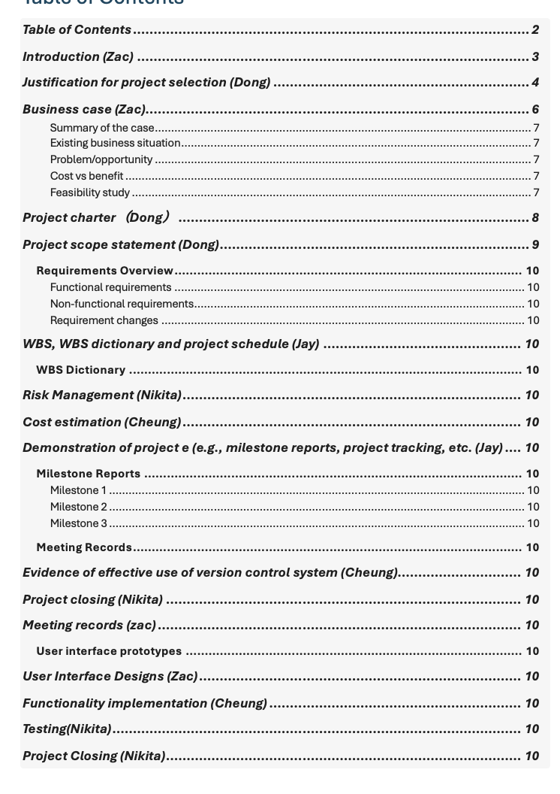

Logo:


